**Assignment - 3**

**Name : V.Naresh Naik**

**Course Tutor : Harshee Pitroda**

**Course Name : Python AI and ML**

**Date : 03.06.2022**

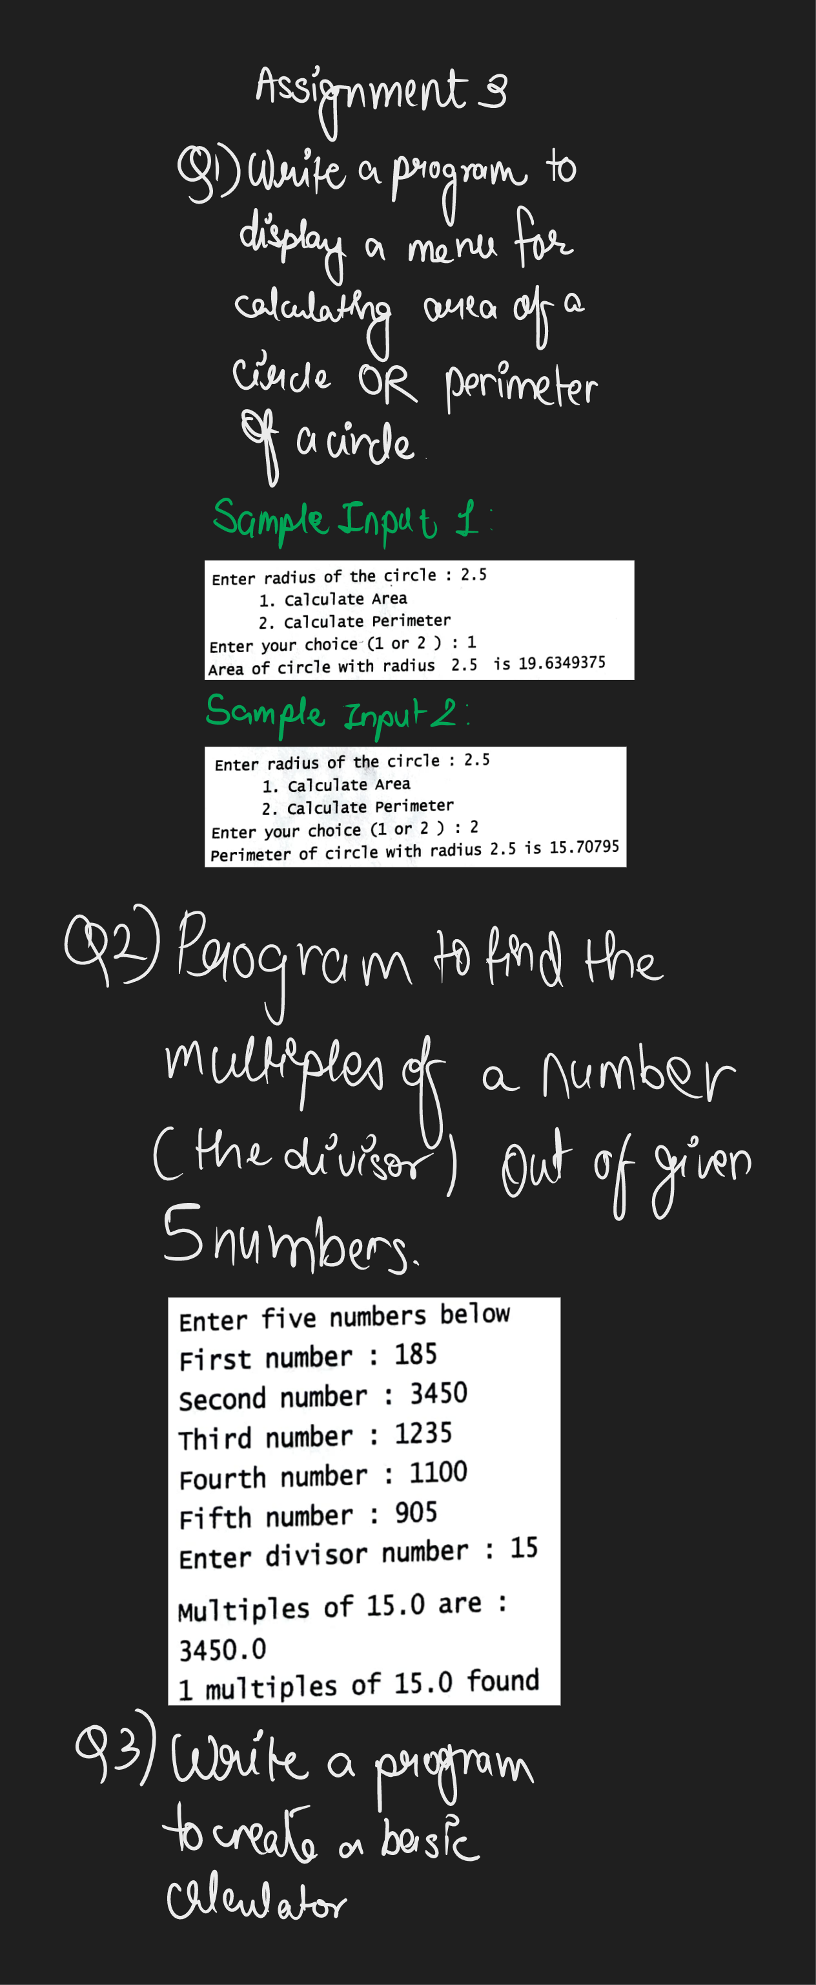

**Q1.** **from math import pi**

**x=float(input('Enter the radius of the circle:'))**

**print(' '*5,' 1.Calculate Area')**

**print(' '*5,' 2.Calculate Perimeter')**

**i=int(input("Enter your choice (1 or 2):"))**

**if x==1:**

**print('Area of the circle with radius {} is {}'.format(x,(pi*x**2)))**

**elif x==2:**

**print('Perimeter of the circle with radius {} is {}'.format(x,(2*pi*x)))**

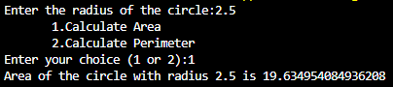

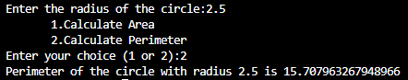

**Q2.**

**print('Enter five numbers below')**

**number1=float(input('First number : '))**

**number2=float(input('Second number : '))**

**number3=float(input('Third number : '))**

**number4=float(input('Fourth number : '))**

**number5=float(input('Fifth number : '))**

**divisor=float(input('Enter divisor number : '))**

**multiples=[]**

**l=[number1,number2,number3,number4,number5]**

**for i in l:**

**if i%divisor==0:**

**multiples.append(i)**

**print('Multiples of {} are {}'.format(divisor,multiples))**

**print('{} multiples of {} found'.format(len(multiples),divisor))**

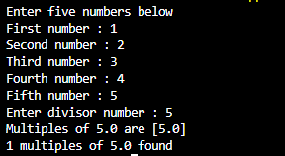

**Q3.**

**x=float(input('Enter number 1: '))**

**y=float(input('Enter number 2: '))**

**print('Select required operation')**

**print('1.Addition')**

**print('2.Subtraction')**

**print('3.Multiplication')**

**print('4.Division')**

**z=int(input('Enter your choice : '))**

**if z==1:**

**print('Sum is ',x+y)**

**elif z==2:**

**print('Difference is ',x-y)**

**elif z==3:**

**print('Product is ',x*y)**

**elif z==4:**

**print('Quotient is ',x/y)**

